CVWC participates in Read Across America
Reads to Silverwood Elementary School First to Third Graders

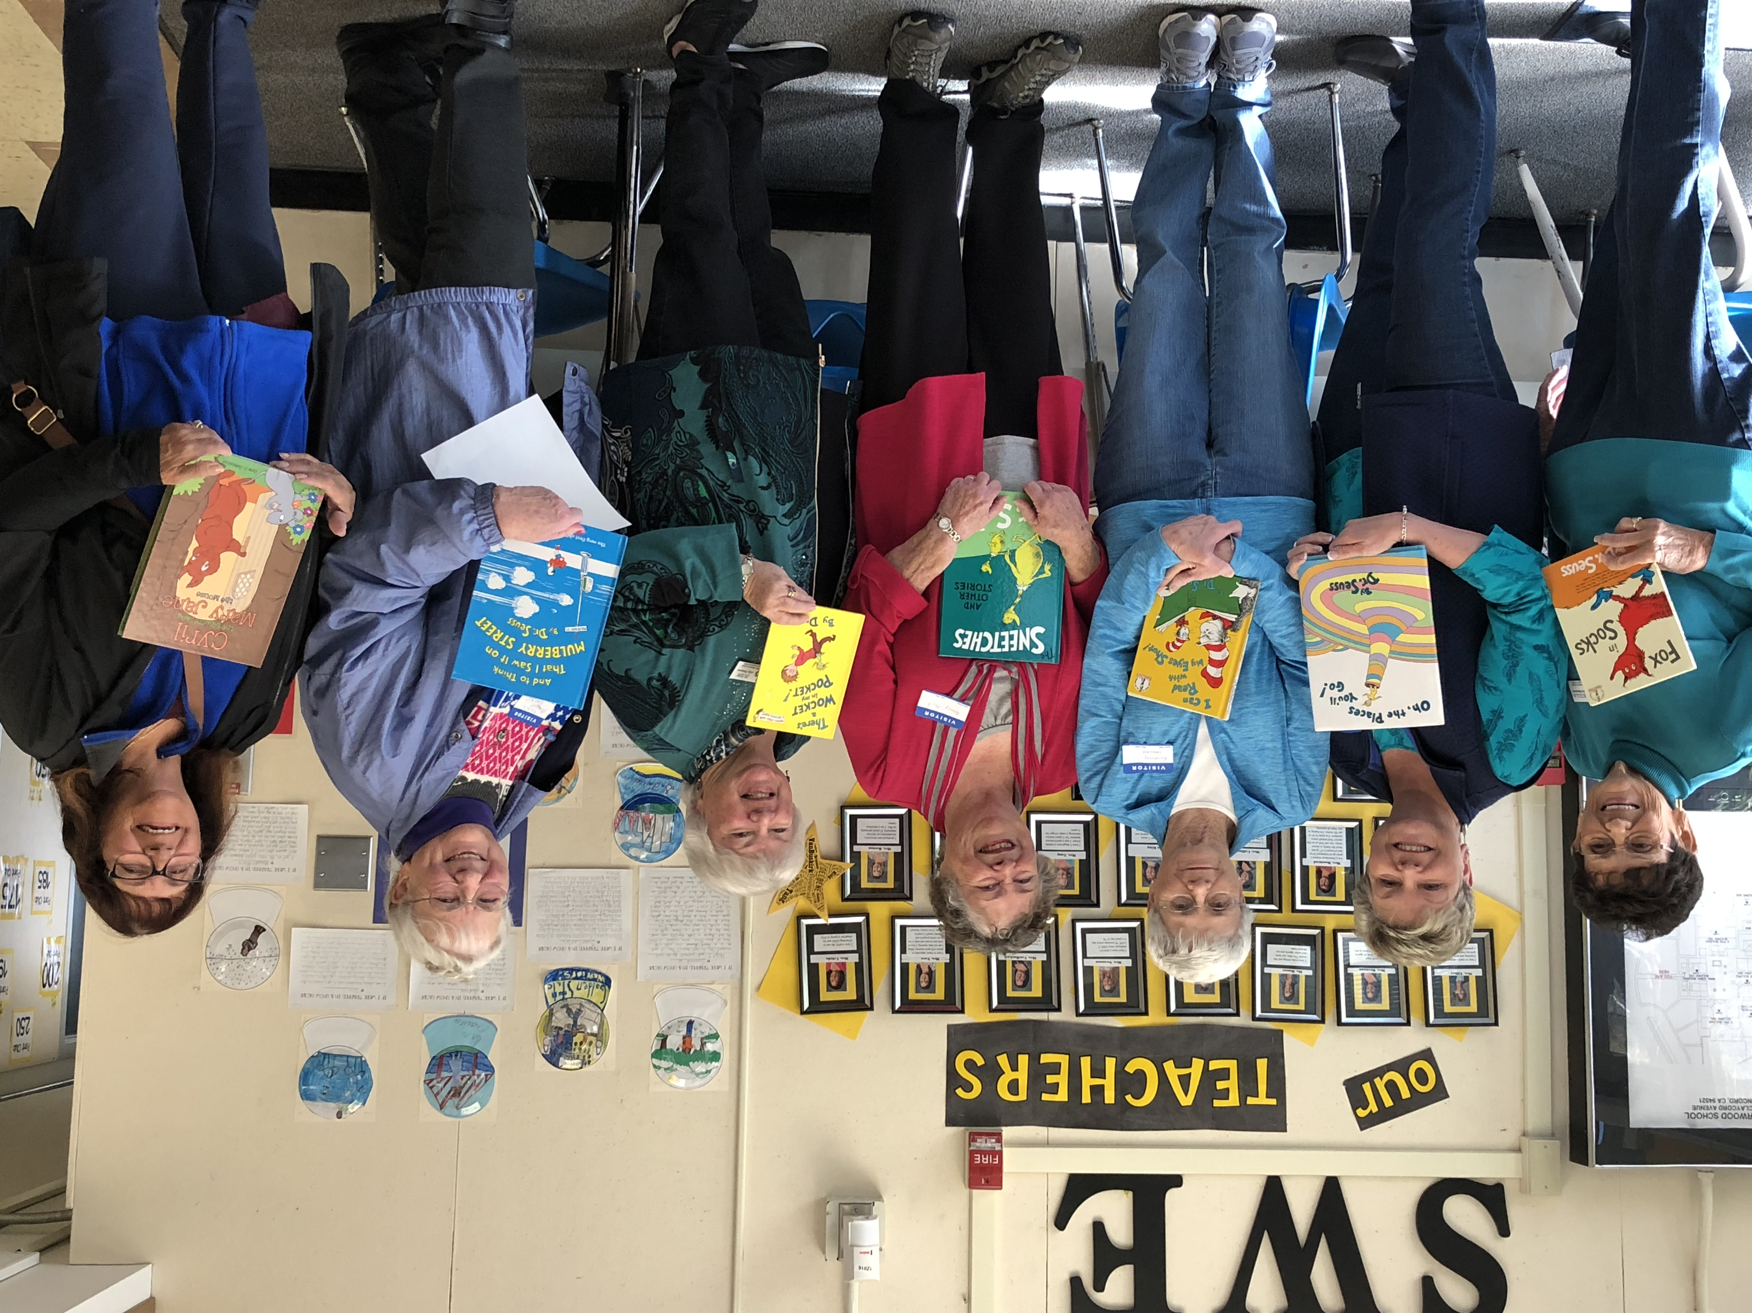

Pictured L to R: Priscilla Manlove, Aleta Huck, Rosemary Harwood, Nancy Boyle, Judy Disbrow, Maggie Gardner and June Gatewood.
On Friday, March 2, the birthday of Dr. Seuss, members of the Clayton Valley Woman’s Club participated in “Read Across America” at Silverwood Elementary School. CVWC members brought books to read to 1st, 2nd and 3rd grade classes. Some of the books were donated to the classrooms. Those reading the books really had a great time sharing their love of reading with the children and judging from the animated response of the children, they enjoyed the experience too!

